1. **What are the three types of architecture in IOT?**

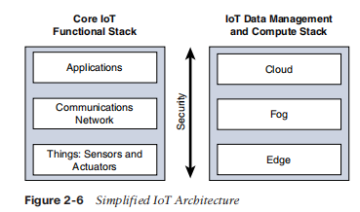

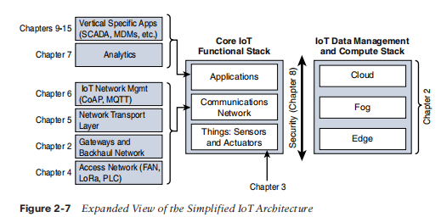

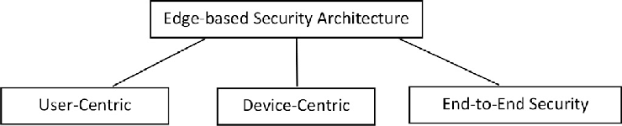

**Device-centric architecture:**

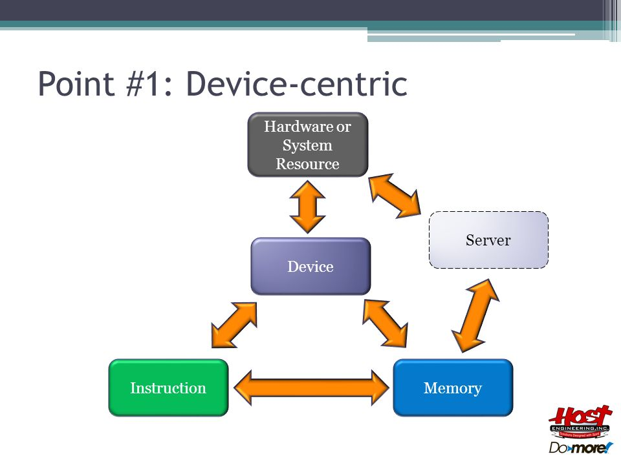

This architecture is based on the concept of having devices that can collect and transmit data directly to the cloud. In this architecture, devices have built-in intelligence and can communicate with other devices or the cloud to share data. The device-centric architecture is ideal for applications that require low latency and real-time response.

Advantages:

Low latency and real-time response

Better control over the data collection process

Devices can operate independently of the network

Lower cost due to fewer required components

Disadvantages:

Limited scalability due to device-level processing and storage limitations

Increased complexity of device firmware and software

More difficult to manage and monitor devices

Limited capacity for data aggregation and preprocessing

Use:

Smart home devices, such as thermostats, lighting systems, and security systems

Wearable health and fitness trackers

Industrial sensors, such as temperature and humidity sensors in manufacturing plants

Asset tracking devices, such as GPS trackers for vehicles and equipment

**Gateway-centric architecture:**

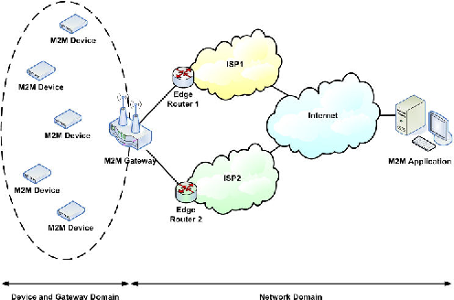

In this architecture, devices are connected to gateways, which act as intermediaries between the devices and the cloud. The gateways perform data aggregation, preprocessing, and filtering before transmitting the data to the cloud. This architecture is useful for applications that require high bandwidth and low latency, but still need some level of preprocessing before data is sent to the cloud.

Advantages:

Improved scalability compared to device-centric architecture

Better data aggregation and preprocessing capabilities

Lower bandwidth requirements for cloud communication

More efficient use of cloud resources

Disadvantages:

Increased cost due to the need for additional gateway hardware

Increased complexity due to the added layer of gateway software and firmware

Single point of failure with gateway device

Increased latency compared to device-centric architecture

Use:

Smart city infrastructure, such as traffic lights and parking sensors

Building automation systems, such as HVAC and lighting controls in commercial buildings

Agricultural monitoring systems, such as soil moisture and nutrient sensors in crops

Industrial automation and control systems, such as conveyor belt sensors in factories

**Cloud-centric architecture:**

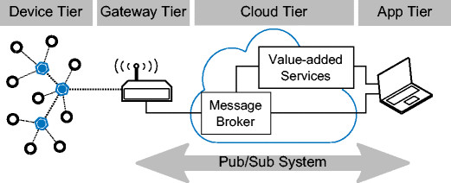

In this architecture, all the devices are connected directly to the cloud. The cloud acts as a central hub that receives data from the devices and performs all the processing and analytics. The cloud-centric architecture is ideal for applications that require massive scalability and a high level of data processing and analytics.

Advantages:

Highest level of scalability due to cloud computing resources

Centralized data processing and analytics

Easy access to data from any location

Lower hardware costs for devices due to less processing requirements

Disadvantages:

High latency due to network communication requirements

Higher bandwidth requirements for cloud communication

Higher risk of security breaches due to a central point of data storage and processing

Limited control over data collection process

Use:

Connected car systems, such as infotainment and remote diagnostics

Healthcare systems, such as telemedicine and remote patient monitoring

Smart grid systems, such as energy consumption monitoring and demand response

Supply chain and logistics systems, such as inventory tracking and optimization

1. **World Forum Standardized Architecture.**

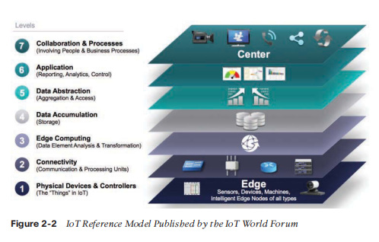

The World Forum Standardized Architecture (WFSA) is a set of standards developed by the World Forum on the Internet of Things (WF-IoT) to provide a framework for IoT device interoperability and data exchange. The WFSA aims to establish a common language and framework for IoT devices and applications, enabling seamless integration and interoperability between different systems and technologies.

The WFSA defines a set of standard protocols, interfaces, and data models that can be used to ensure interoperability between different IoT devices and applications. The WFSA includes four layers:

* Device layer: This layer defines the hardware and software components of IoT devices, including sensors, actuators, processors, and communication interfaces. The device layer also includes standardized device profiles that define the functionality and capabilities of different types of IoT devices.
* Network layer: This layer defines the communication protocols and interfaces used to connect IoT devices to the internet and to other devices. The network layer includes standard protocols such as TCP/IP, HTTP, and MQTT, as well as interfaces for device discovery and configuration.
* Service layer: This layer defines the services that are provided by IoT devices and applications, including data collection, storage, processing, and analysis. The service layer also includes standard data models and technologys that enable the semantic interoperability of IoT data.
* Application layer: This layer defines the interfaces and protocols used by applications to interact with IoT devices and services. The application layer includes standard APIs and interfaces for accessing IoT data and services, as well as standard data formats for data exchange between applications.

The WFSA aims to provide a standardized framework for IoT device interoperability and data exchange, enabling seamless integration and interoperability between different systems and technologies. By providing a common language and framework for IoT devices and applications, the WFSA can help to accelerate the development and adoption of IoT technologies, and enable new applications and services that were previously not possible.

**Applications:**

The World Forum Standardized Architecture (WFSA) was created by the World Forum on the Internet of Things (WF-IoT) in 2014. The WF-IoT is an international organization that brings together industry leaders, researchers, and policymakers to promote the development and adoption of IoT technologies. The WF-IoT was founded in 2013, and the WFSA was one of its earliest initiatives. Since its creation, the WFSA has been continuously updated and improved to keep pace with the rapidly evolving IoT landscape, and to address emerging challenges and opportunities in the field.

The World Forum Standardized Architecture (WFSA) has been used in a variety of real-world applications, including:

Smart cities: The WFSA has been used to develop interoperable and standardized solutions for smart city applications, such as traffic management, waste management, and environmental monitoring. By using the WFSA, different smart city systems can communicate with each other using common protocols and data models, enabling better coordination and more efficient use of resources.

Industrial automation: The WFSA has been used in industrial automation and control systems to enable interoperability between different types of sensors, actuators, and controllers. By using the WFSA, industrial systems can communicate and exchange data in a standardized way, making it easier to integrate new devices and technologies into existing systems.

Healthcare: The WFSA has been used to develop interoperable and secure solutions for healthcare applications, such as remote patient monitoring and telemedicine. By using the WFSA, different healthcare devices and systems can communicate and exchange data in a standardized way, ensuring that patient data is consistent and accurate.

Agriculture: The WFSA has been used in agriculture to develop interoperable and standardized solutions for precision farming applications, such as soil moisture monitoring and crop management. By using the WFSA, farmers can integrate different sensors and devices into their systems, enabling better decision-making and more efficient use of resources.

Overall, the WFSA has been used in a wide range of applications to enable interoperability and data exchange between different IoT devices and systems, leading to more efficient and effective use of resources and better outcomes for users.

1. **Data Management and Compute Stack.**

The data management and compute stack for IoT refers to the various layers of technologies and software that are used to manage and process data generated by IoT devices. The stack typically includes several layers, each with its own set of technologies and tools, as outlined below:

* Data acquisition layer: The data acquisition layer involves collecting and aggregating data from IoT devices. This layer includes protocols such as MQTT and CoAP, as well as data formats such as JSON and XML.
* Data ingestion layer: The data ingestion layer involves receiving and processing data from the data acquisition layer. This layer includes technologies such as Apache Kafka and RabbitMQ, which are used to manage the flow of data from IoT devices.
* Data storage layer: The data storage layer involves storing and managing data generated by IoT devices. This layer includes technologies such as Hadoop, Apache Cassandra, and MongoDB, which are used to store and manage large volumes of data.
* Data processing layer: The data processing layer involves processing and analyzing data generated by IoT devices. This layer includes technologies such as Apache Spark and Apache Flink, which are used to perform real-time data processing and analytics.
* Data visualization layer: The data visualization layer involves presenting data generated by IoT devices in a meaningful and actionable way. This layer includes technologies such as Kibana and Grafana, which are used to create dashboards and visualizations that enable users to monitor and analyze IoT data.
* Application layer: The application layer involves using the data generated by IoT devices to create new applications and services. This layer includes technologies such as Node.js, Python, and Java, which are used to build applications and services that leverage IoT data.

Overall, the data management and compute stack for IoT involves a wide range of technologies and tools that are used to manage, process, and analyze data generated by IoT devices. By leveraging these technologies, organizations can gain valuable insights from IoT data, enabling them to make better decisions, improve operations, and create new services and products.

1. **Convergence of IT and OT.**

The convergence of IT (Information Technology) and OT (Operational Technology) refers to the integration of these two traditionally separate domains of technology within an organization. IT refers to the use of computers, software, and networking technologies for information processing and management, while OT refers to the use of technology to monitor and control physical processes, such as those found in manufacturing, energy, and transportation.

The convergence of IT and OT has been driven by several factors, including the rise of IoT (Internet of Things) technologies, the growing use of big data and analytics, and the need for real-time visibility and control over industrial processes. Some of the key aspects of the convergence of IT and OT include:

* Integration of networks: In the past, IT and OT networks were often separate and isolated from each other. However, the convergence of these two domains has led to the integration of networks, enabling real-time data exchange and communication between different systems and devices.
* Use of common platforms and tools: The convergence of IT and OT has led to the use of common platforms and tools for data management, analytics, and visualization. This enables organizations to gain insights from data generated by both IT and OT systems, leading to better decision-making and improved operational efficiency.
* Security challenges: The convergence of IT and OT also poses new security challenges, as industrial systems may be more vulnerable to cyber attacks when connected to IT networks. As a result, organizations must take steps to secure their networks and systems, such as implementing firewalls, access controls, and other security measures.
* Collaboration between IT and OT teams: The convergence of IT and OT requires close collaboration between these two traditionally separate teams. This collaboration is essential for ensuring that both IT and OT systems are properly integrated, secured, and managed.

Overall, the convergence of IT and OT has led to significant benefits for organizations, including improved operational efficiency, increased visibility into industrial processes, and better decision-making. However, it also poses new challenges and requires careful planning and collaboration between IT and OT teams.

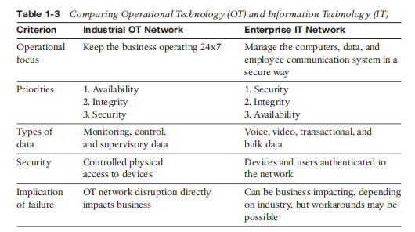

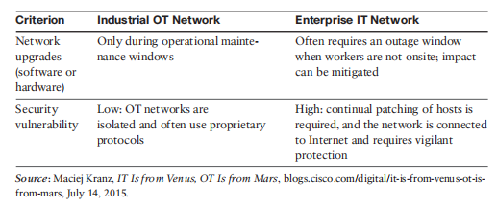

1. **IM2M Architecture.**

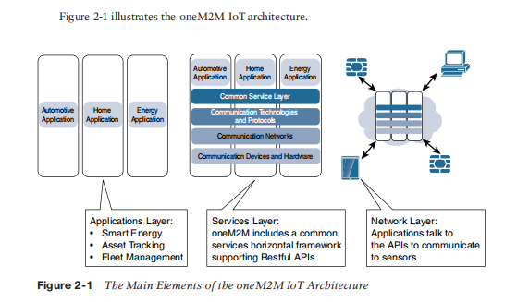

IM2M (Inter-Model and Intra-Model Management) architecture is a framework for managing and integrating different models in the context of IoT (Internet of Things) systems. The IM2M architecture is designed to address the challenges of integrating different models that are used for different purposes in IoT systems, such as physical models, communication models, and information models.

The IM2M architecture consists of several layers, as outlined below:

* Sensor layer: The sensor layer includes the physical sensors and devices that generate data in an IoT system.
* Network layer: The network layer includes the communication technologies and protocols used to connect IoT devices to the internet and to each other.
* Service layer: The service layer includes the various services that are provided by an IoT system, such as data processing, storage, and analysis.
* Information layer: The information layer includes the various models that are used to represent the data generated by an IoT system, such as physical models, communication models, and information models.
* Management layer: The management layer includes the various tools and technologies that are used to manage and integrate the different models used in an IoT system.

The key features of the IM2M architecture include:

* Model management: The IM2M architecture provides tools and technologies for managing the different models used in an IoT system, including modeling languages, transformation tools, and validation tools.
* Model integration: The IM2M architecture provides tools and technologies for integrating different models used in an IoT system, including mapping and transformation tools.
* Semantic interoperability: The IM2M architecture enables semantic interoperability between different models used in an IoT system, allowing for better communication and collaboration between different components of the system.
* Flexibility: The IM2M architecture is designed to be flexible and adaptable, allowing for the integration of new models as they are developed.

Overall, the IM2M architecture is a powerful framework for managing and integrating different models in the context of IoT systems. By providing tools and technologies for model management, integration, and semantic interoperability, the IM2M architecture enables organizations to build more robust and flexible IoT systems that can effectively manage and process data from a wide range of sources.

The IM2M architecture has several real-life applications in the context of IoT systems. Some examples include:

* Smart buildings: The IM2M architecture can be used in the context of smart buildings, where it can be used to manage and integrate different models related to building automation, energy management, and security. By using the IM2M architecture, building managers can more effectively monitor and control various building systems, leading to increased energy efficiency and improved occupant comfort and safety.
* Industrial automation: The IM2M architecture can be used in the context of industrial automation, where it can be used to manage and integrate different models related to process control, manufacturing, and quality assurance. By using the IM2M architecture, manufacturers can more effectively monitor and control various industrial processes, leading to increased efficiency and reduced costs.
* Healthcare: The IM2M architecture can be used in the context of healthcare, where it can be used to manage and integrate different models related to patient monitoring, medical devices, and healthcare information systems. By using the IM2M architecture, healthcare providers can more effectively monitor and treat patients, leading to improved patient outcomes and reduced costs.
* Transportation: The IM2M architecture can be used in the context of transportation, where it can be used to manage and integrate different models related to traffic management, vehicle control, and logistics. By using the IM2M architecture, transportation providers can more effectively manage and optimize various transportation systems, leading to reduced congestion and improved efficiency.

Overall, the IM2M architecture has a wide range of real-life applications in the context of IoT systems. By enabling better management and integration of different models, the IM2M architecture can help organizations to build more efficient, flexible, and effective IoT systems that can drive innovation and improve outcomes in various industries.

1. **Difference Between MQTT and HTTP.**

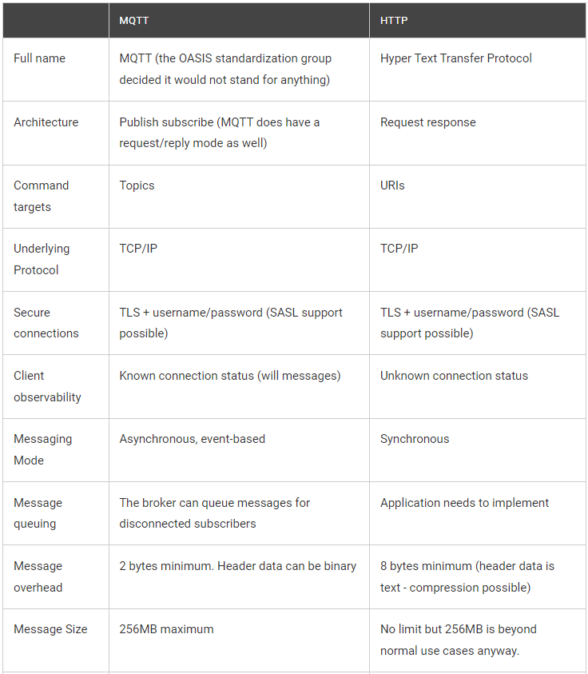

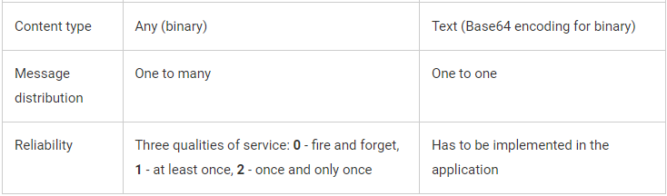

To illustrate the differences between MQTT and HTTP based on real-life applications, consider the following examples:

Smart home automation: MQTT is often used in smart home automation systems, where devices such as sensors, thermostats, and lights need to exchange real-time data in order to control the environment. For example, a smart thermostat may publish temperature data to an MQTT broker, which is then subscribed to by other devices in the home, such as lights and fans. MQTT is well-suited for this type of application because it provides real-time data exchange with low overhead.

Web-based applications: HTTP is often used in web-based applications, such as e-commerce websites or social media platforms, where users interact with servers to request and receive information. For example, a user may make a request to a server to retrieve product information, and the server will respond with the requested data. HTTP is well-suited for this type of application because it provides a reliable request-response mechanism with support for caching and other web-specific features.

Industrial automation: MQTT is often used in industrial automation systems, such as in manufacturing plants or oil refineries, where sensors and other devices need to exchange real-time data in order to control and monitor various processes. For example, sensors may publish data on temperature, pressure, or flow rate to an MQTT broker, which is then subscribed to by other devices in the system to trigger actions or alarms. MQTT is well-suited for this type of application because it provides low latency and high reliability for real-time data exchange.

Mobile applications: HTTP is often used in mobile applications, such as those used for social media or news feeds, where users interact with servers to request and receive information. For example, a user may make a request to a server to retrieve the latest news articles, and the server will respond with the requested data. HTTP is well-suited for this type of application because it provides a flexible and reliable mechanism for data exchange over mobile networks.

Overall, the choice between MQTT and HTTP depends on the nature of the application and the specific requirements for data exchange. MQTT is often used in real-time applications that require low latency and high reliability, while HTTP is often used in applications that require reliable request-response mechanisms and support for web-specific features.

1. **All characteristics of sensors.**

Sensors are essential components of the Internet of Things (IoT) ecosystem, as they are responsible for collecting data from the physical world and transmitting it to other devices or systems for processing and analysis. The following are some of the key characteristics that sensors for IoT applications should possess:

* Sensing range: Sensors should be able to detect signals within a certain range, depending on the application requirements. For example, a temperature sensor may have a sensing range of -40°C to +125°C, while a humidity sensor may have a sensing range of 0-100% relative humidity.
* Accuracy: Sensors should be accurate in their measurements, with low levels of error or uncertainty. The level of accuracy required will depend on the application requirements, but in general, sensors for IoT applications should have accuracy within a few percentage points.
* Sensitivity: Sensors should be sensitive enough to detect small changes in the physical world. For example, a motion sensor should be able to detect small movements, while a light sensor should be able to detect changes in light intensity.
* Power consumption: Sensors for IoT applications should be designed with low power consumption in mind, as they may need to operate on battery power or other low-power sources. This can be achieved through various techniques, such as using low-power electronics, optimizing sampling rates, or using sleep modes.
* Communication protocol: Sensors should be able to communicate with other devices or systems using a standardized protocol, such as MQTT or HTTP, in order to enable seamless integration with other IoT components.
* Durability: Sensors for IoT applications should be durable and reliable, as they may be exposed to various environmental conditions and may need to operate continuously for long periods of time.
* Scalability: Sensors should be designed to be scalable, allowing for easy deployment and management of large numbers of sensors in a network.
* Cost: Sensors for IoT applications should be cost-effective, as the cost of sensors can be a significant factor in the overall cost of an IoT system.

Overall, sensors for IoT applications should be designed with a combination of these characteristics in mind, depending on the specific requirements of the application. By choosing sensors with the right combination of characteristics, developers can create IoT systems that are efficient, reliable, and scalable.

1. **All sensors of the Smartphone.**

Modern smartphones are equipped with a wide range of sensors, which are used to collect data about the user and the environment. The following is a list of common sensors found in smartphones:

333333333

* Accelerometer: Measures the phone's acceleration and tilt, and is used to detect motion, shake, and rotation.
* Gyroscope: Measures the phone's rotation and angular velocity, and is used to provide more accurate orientation information than the accelerometer alone.
* Magnetometer: Measures the strength and direction of the Earth's magnetic field, and is used for compass and navigation applications.
* Proximity sensor: Detects when the phone is close to the user's face during a phone call, and turns off the display to conserve power and prevent accidental touches.
* Ambient light sensor: Measures the level of ambient light in the environment, and adjusts the screen brightness accordingly to optimize power consumption and visibility.
* Barometer: Measures air pressure, and is used for weather and altitude applications.
* GPS: Uses satellite signals to determine the phone's location, and is used for navigation, mapping, and location-based services.
* Infrared sensor: Used for remote control applications, allowing the phone to control devices such as TVs and air conditioners.
* Fingerprint sensor: Used for biometric authentication, allowing the user to unlock the phone and make secure transactions with their fingerprint.
* Heart rate sensor: Measures the user's heart rate through their fingertip, and is used for fitness and health monitoring applications.
* Camera sensor: Used to capture images and videos, and may include additional sensors such as autofocus, image stabilization, and depth sensing.

Overall, the various sensors in a smartphone enable a wide range of functionality, from basic tasks such as displaying the time and adjusting the screen brightness, to more advanced applications such as navigation and biometric authentication.

**Explain Each Sensor in detail:**

* Accelerometer: An accelerometer is a sensor that measures the phone's acceleration and tilt. It is typically used to detect motion, such as when the phone is shaken or rotated. By measuring changes in the phone's acceleration, the accelerometer can provide data for applications such as games, fitness tracking, and gesture recognition.
* Gyroscope: A gyroscope is a sensor that measures the phone's rotation and angular velocity. It is used to provide more accurate orientation information than the accelerometer alone, allowing for more precise control in games and other applications. The gyroscope is also used for motion tracking and stabilization in photography and video recording.
* Magnetometer: A magnetometer is a sensor that measures the strength and direction of the Earth's magnetic field. It is used for compass and navigation applications, allowing the phone to determine its orientation and direction of travel. The magnetometer can also be used to detect magnetic fields from nearby devices, such as credit card readers and security systems.
* Proximity sensor: A proximity sensor is a sensor that detects when the phone is close to the user's face during a phone call. It is typically located near the phone's earpiece, and uses infrared or other technologies to detect the presence of an object nearby. When the sensor is triggered, the phone turns off the display to conserve power and prevent accidental touches.
* Ambient light sensor: An ambient light sensor is a sensor that measures the level of ambient light in the environment. It is typically located near the phone's front-facing camera, and adjusts the screen brightness accordingly to optimize power consumption and visibility. By detecting changes in light levels, the ambient light sensor can also be used to trigger various actions, such as turning on the flash when taking a photo in low light.
* Barometer: A barometer is a sensor that measures air pressure. It is used for weather and altitude applications, allowing the phone to determine its elevation and estimate changes in weather conditions. The barometer is typically used in conjunction with other sensors, such as GPS and accelerometer, to provide more accurate location and orientation information.
* GPS: GPS stands for Global Positioning System, and is a sensor that uses satellite signals to determine the phone's location. It is used for navigation, mapping, and location-based services, such as finding nearby restaurants or tracking the location of a package. By using multiple satellite signals, the GPS sensor can provide highly accurate location information, typically within a few meters.
* Infrared sensor: An infrared sensor is used for remote control applications, allowing the phone to control devices such as TVs and air conditioners. The sensor emits an infrared signal, which is interpreted by the device being controlled. Infrared sensors are typically located on the top or bottom edge of the phone, and can be used in conjunction with apps or built-in software to control a wide range of devices.
* Fingerprint sensor: A fingerprint sensor is used for biometric authentication, allowing the user to unlock the phone and make secure transactions with their fingerprint. The sensor typically uses capacitive or optical technology to scan the user's fingerprint, and compares it to a stored database to verify their identity. Fingerprint sensors can be located on the phone's home button, power button, or back panel, depending on the model.
* Heart rate sensor: A heart rate sensor is used to measure the user's heart rate through their fingertip. The sensor typically uses optical technology to detect changes in blood flow, and can be used for fitness and health monitoring applications, such as tracking exercise intensity and monitoring stress levels.
* Camera sensor: A camera sensor is used to capture images and videos, and may include additional sensors such as autofocus, image stabilization, and depth sensing.

**IoT Access Technologys:**

The previous section describes criteria that help you in evaluating IoT constrained network technologies for proper design and operations. This section provides an overview of the main IoT access technologies. The technologies highlighted here are the ones that are seen as having market and/or mind share. Therefore, you should have a basic familiarity with them as they are fundamental to many IoT conversations.

For each of the IoT access technologies discussed in this chapter, a common information set is being provided. Particularly, the following topics are addressed for each IoT access technology:

* Standardization and alliances: The standards bodies that maintain the protocols for a technology Physical layer: The wired or wireless methods and relevant frequencies
* MAC layer: Considerations at the Media Access Control (MAC) layer, which bridges the physical layer with data link control
* Topology: The topologies supported by the technology
* Security: Security aspects of the technology
* Competitive technologies: Other technologies that are similar and may be suitable alternatives to the given technology

1. **Classification of sensors based on access technology and distance.**

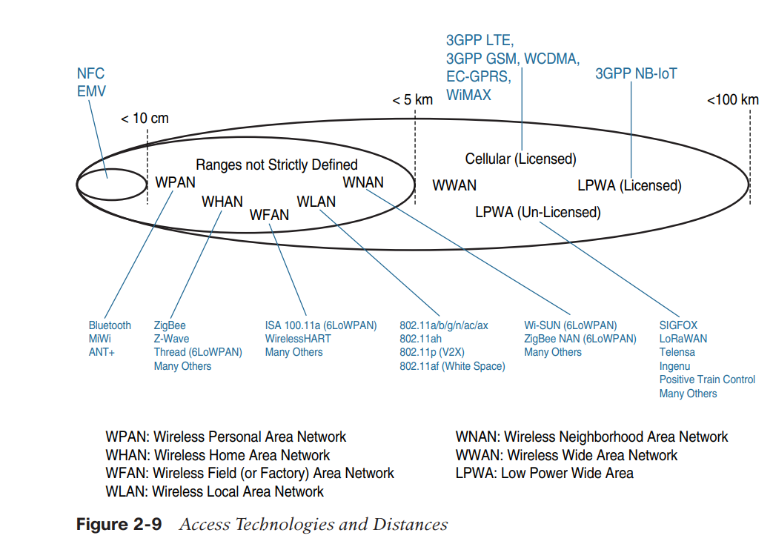

Note that the ranges in Figure 2-9 are inclusive. For example, cellular is indicated for transmissions beyond 5 km, but you could achieve a successful cellular transmission at shorter range (for example, 100 m). By contrast, ZigBee is expected to be efficient over a range of a few tens of meters, but you would not expect a successful ZigBee transmission over a range of 10 km. Range estimates are grouped by category names that illustrate the environment or the vertical where data collection over that range is expected. Common groups are as follows:

* PAN (personal area network): Scale of a few meters. This is the personal space around a person. A common wireless technology for this scale is Bluetooth.
* HAN (home area network): Scale of a few tens of meters. At this scale, common wireless technologies for IoT include ZigBee and Bluetooth Low Energy (BLE).
* NAN (neighborhood area network): Scale of a few hundreds of meters. The term NAN is often used to refer to a group of house units from which data is collected.
* FAN (field area network): Scale of several tens of meters to several hundred meters. FAN typically refers to an outdoor area larger than a single group of house units. The FAN is often seen as “open space” (and therefore not secured and not controlled). A FAN is sometimes viewed as a group of NANs, but some verticals see the FAN as a group of HANs or a group of smaller outdoor cells. As you can see, FAN and NAN may sometimes be used interchangeably. In most cases, the vertical context is clear enough to determine the grouping hierarchy.
* Note that the ranges in Figure 2-9 are inclusive. For example, cellular is indicated for transmissions beyond 5 km, but you could achieve a successful cellular transmission at shorter range (for example, 100 m). By contrast, ZigBee is expected to be efficient over a range of a few tens of meters, but you would not expect a successful ZigBee transmission over a range of 10 km. Range estimates are grouped by category names that illustrate the environment or the vertical where data collection over that range is expected. Common groups are as follows:
* PAN (personal area network): Scale of a few meters. This is the personal space around a person. A common wireless technology for this scale is Bluetooth.
* HAN (home area network): Scale of a few tens of meters. At this scale, common wireless technologies for IoT include ZigBee and Bluetooth Low Energy (BLE).
* NAN (neighborhood area network): Scale of a few hundreds of meters. The term NAN is often used to refer to a group of house units from which data is collected.
* FAN (field area network): Scale of several tens of meters to several hundred meters. FAN typically refers to an outdoor area larger than a single group of house units. The FAN is often seen as “open space” (and therefore not secured and not controlled). A FAN is sometimes viewed as a group of NANs, but some verticals see the FAN as a group of HANs or a group of smaller outdoor cells. As you can see, FAN and NAN may sometimes be used interchangeably. In most cases, the vertical context is clear enough to determine the grouping hierarchy.

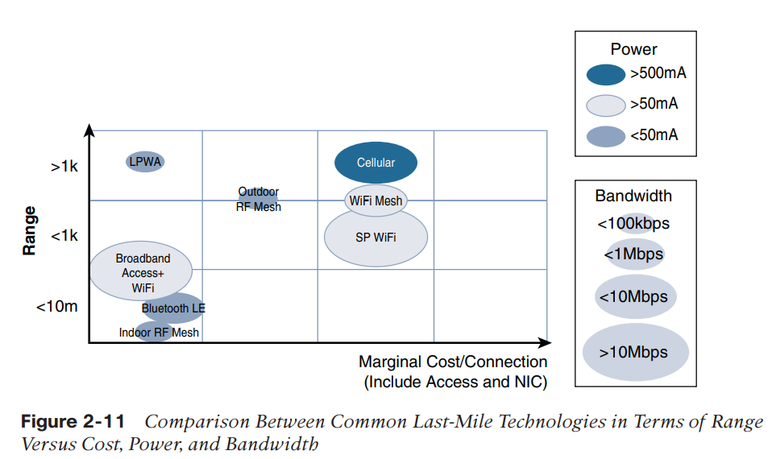

Similar ranges also do not mean similar topologies. Some technologies offer flexible connectivity structure to extend communication possibilities:

* **Point-to-point topologies:** These topologies allow one point to communicate with another point. This topology in its strictest sense is uncommon for IoT access, as it would imply that a single object can communicate only with a single gateway. However, several technologies are referred to as “point-to-point” when each object establishes an individual session with the gateway. The “point-to-point” concept, in that case, often refers to the communication structure more than the physical topology.
* **Point-to-multi point topologies:** These topologies allow one point to communicate with more than one other point. Most IoT technologies where one or more than one gateways communicate with multiple smart objects are in this category. However, depending on the features available on each communicating mode, several sub-types need to be considered. A particularity of IoT networks is that some nodes (for example, sensors) support both data collection and forwarding functions, while some other nodes (for example, some gateways) collect the smart object data, sometimes instruct the sensor to perform specific operations, and also interface with other networks or possibly other gateways. For this reason, some technologies categorize the nodes based on the functions (described by a protocol) they implement. An example of a technology that categorizes nodes based on their function is IEEE 802.15.4, which is covered in depth in Chapter 4. Although 802.15.4 is used as an example in this section, the same principles may apply to many other technologies. Applications leveraging IEEE 802.15.4 commonly rely on the concept of an end device (a sensor) collecting data and transmitting the data to a collector. Sensors need to be small and are often mobile (or movable). When mobile, these sensors are therefore commonly battery operated. To form a network, a device needs to connect with another device. When both devices fully implement the protocol stack functions, they can form a peer-to-peer network. However, in many cases, one of the devices collects data from the others. For example, in a house, temperature sensors may be deployed in each room or each zone of the house, and they may communicate with a central point where temperature is displayed and controlled. A room sensor does not need to communicate with another room sensor. In that case, the control point is at the center of the network. The network forms a star topology, with the control point at the hub and the sensors at the spokes. In such a configuration, the central point can be in charge of the overall network coordination, taking care of the beacon transmissions and connection to each sensor. In the IEEE 802.15.4 standard, the central point is called a coordinator for the network. With this type of deployment, each sensor is not intended to do anything other than communicate with the coordinator in a master/slave type of relationship. The sensor can implement a subset of protocol functions to perform just a specialized part (communication with the coordinator). Such a device is called a reduced-function device (RFD). An RFD cannot be a coordinator. An RFD also cannot implement direct communications to another RFD. The coordinator that implements the full network functions is called, by contrast, a full function device (FFD). An FFD can communicate directly with another FFD or with more than one FFD, forming multiple peer-to-peer connections. Topologies where each FFD has a unique path to another FFD are called cluster tree topologies. FFDs in the cluster tree may have RFDs, resulting in a cluster star topology. Figure 2-12 illustrates these topologies.

-----------------------------------------------------------------------------------------------------------------

* Accelerometer: Access technology - wired or wireless (Bluetooth, Wi-Fi), Distance - short range (within a few meters)
* Gyroscope: Access technology - wired or wireless (Bluetooth, Wi-Fi), Distance - short range (within a few meters)
* Magnetometer: Access technology - wired or wireless (Bluetooth, Wi-Fi), Distance - short range (within a few meters)
* Proximity sensor: Access technology - wired or wireless (Bluetooth, Wi-Fi), Distance - short range (within a few meters)
* Ambient light sensor: Access technology - wired or wireless (Bluetooth, Wi-Fi), Distance - short range (within a few meters)
* Barometer: Access technology - wired or wireless (Bluetooth, Wi-Fi), Distance - short range (within a few meters)
* GPS: Access technology - wireless (satellite), Distance - long range (global)
* Infrared sensor: Access technology - wired or wireless (Bluetooth, Wi-Fi), Distance - short range (within a few meters)
* Fingerprint sensor: Access technology - wired or wireless (Bluetooth, Wi-Fi), Distance - short range (within a few meters)
* Heart rate sensor: Access technology - wired or wireless (Bluetooth, Wi-Fi), Distance - short range (within a few meters)
* Camera sensor: Access technology - wired or wireless (Bluetooth, Wi-Fi), Distance - short range (within a few meters)

1. **Range and classification of access technology(With Graph)**

**Graph is in above question**

* Personal Area Network (PAN): Typically used for communication within a few meters or centimeters, such as with Bluetooth or Zigbee.
* Local Area Network (LAN): Typically used for communication within a few hundred meters, such as with Wi-Fi.
* Wide Area Network (WAN): Typically used for communication over longer distances, such as with cellular networks, satellite, or LPWAN (Low Power Wide Area Networks) like LoRaWAN and Sigfox.
* Global Area Network (GAN): Typically used for global communication, such as with satellite networks.

The range of the access technology used for IoT sensors varies depending on the application requirements. For example, some sensors may require only short-range communication with low data rates, while others may require long-range communication with high data rates. The choice of access technology will depend on factors such as the application requirements, available infrastructure, and cost.

1. **IOT data management and compute stack.**

The IoT data management and compute stack is a framework for managing and processing data generated by IoT devices. It is a complex system that consists of multiple layers, each with its own set of functions and capabilities. Here is a brief overview of each layer:

* Device Layer: This is the lowest layer of the IoT stack and consists of the physical devices that collect and transmit data. These devices can include sensors, actuators, and other types of IoT devices.
* Connectivity Layer: This layer provides the infrastructure and protocols for connecting IoT devices to the internet or a local network. It can include wired and wireless communication technologies such as Bluetooth, Wi-Fi, Zigbee, and cellular networks.
* Data Management Layer: This layer is responsible for managing the data generated by IoT devices. It includes functions such as data ingestion, data storage, and data processing. Data can be stored on the device itself, in the cloud, or in a combination of both.
* Analytics Layer: This layer is responsible for analyzing and processing the data collected from IoT devices. It can include functions such as data mining, machine learning, and artificial intelligence.
* Application Layer: This layer provides the interface for end-users to interact with IoT systems. It can include web and mobile applications, dashboards, and other user interfaces.
* Security Layer: This layer is responsible for ensuring the security and privacy of IoT systems. It can include functions such as access control, authentication, and encryption.

The IoT data management and compute stack is a highly scalable and flexible framework that can be customized to meet the specific needs of different IoT applications. It provides a structured approach to managing and processing data generated by IoT devices, enabling organizations to derive insights and make informed decisions.

1. **Why Fog computing and edge computing?**

Fog computing and edge computing are two approaches to processing data that are becoming increasingly popular as the Internet of Things (IoT) continues to grow. While both approaches involve processing data at the edge of the network rather than in the cloud, they have different characteristics and use cases. Here are some reasons why both fog computing and edge computing are important:

**Fog computing:**

* Reduces the need for data to be sent to the cloud, which can be costly and time-consuming
* Provides faster response times and lower latency for applications that require real-time processing
* Enables processing to be performed closer to the source of the data, which can help to reduce network congestion and improve reliability
* Allows for more efficient use of network resources by distributing processing tasks across multiple devices
* Can be used in a wide range of industries, including healthcare, manufacturing, and transportation

**Edge computing:**

* Enables processing to be performed on devices that have limited processing power or storage capacity
* Provides real-time processing and decision-making capabilities for applications that require fast response times
* Reduces the need for data to be sent to the cloud, which can help to reduce network latency and improve reliability
* Can be used in a wide range of industries, including retail, smart homes, and wearables
* Enables processing to be performed offline, which can be useful in environments with limited or no network connectivity
* In summary, both fog computing and edge computing are important approaches to processing data at the edge of the network. While fog computing is primarily focused on reducing network latency and improving reliability, edge computing is focused on enabling processing to be performed on devices with limited processing power or storage capacity. Both approaches have a wide range of use cases across a variety of industries.

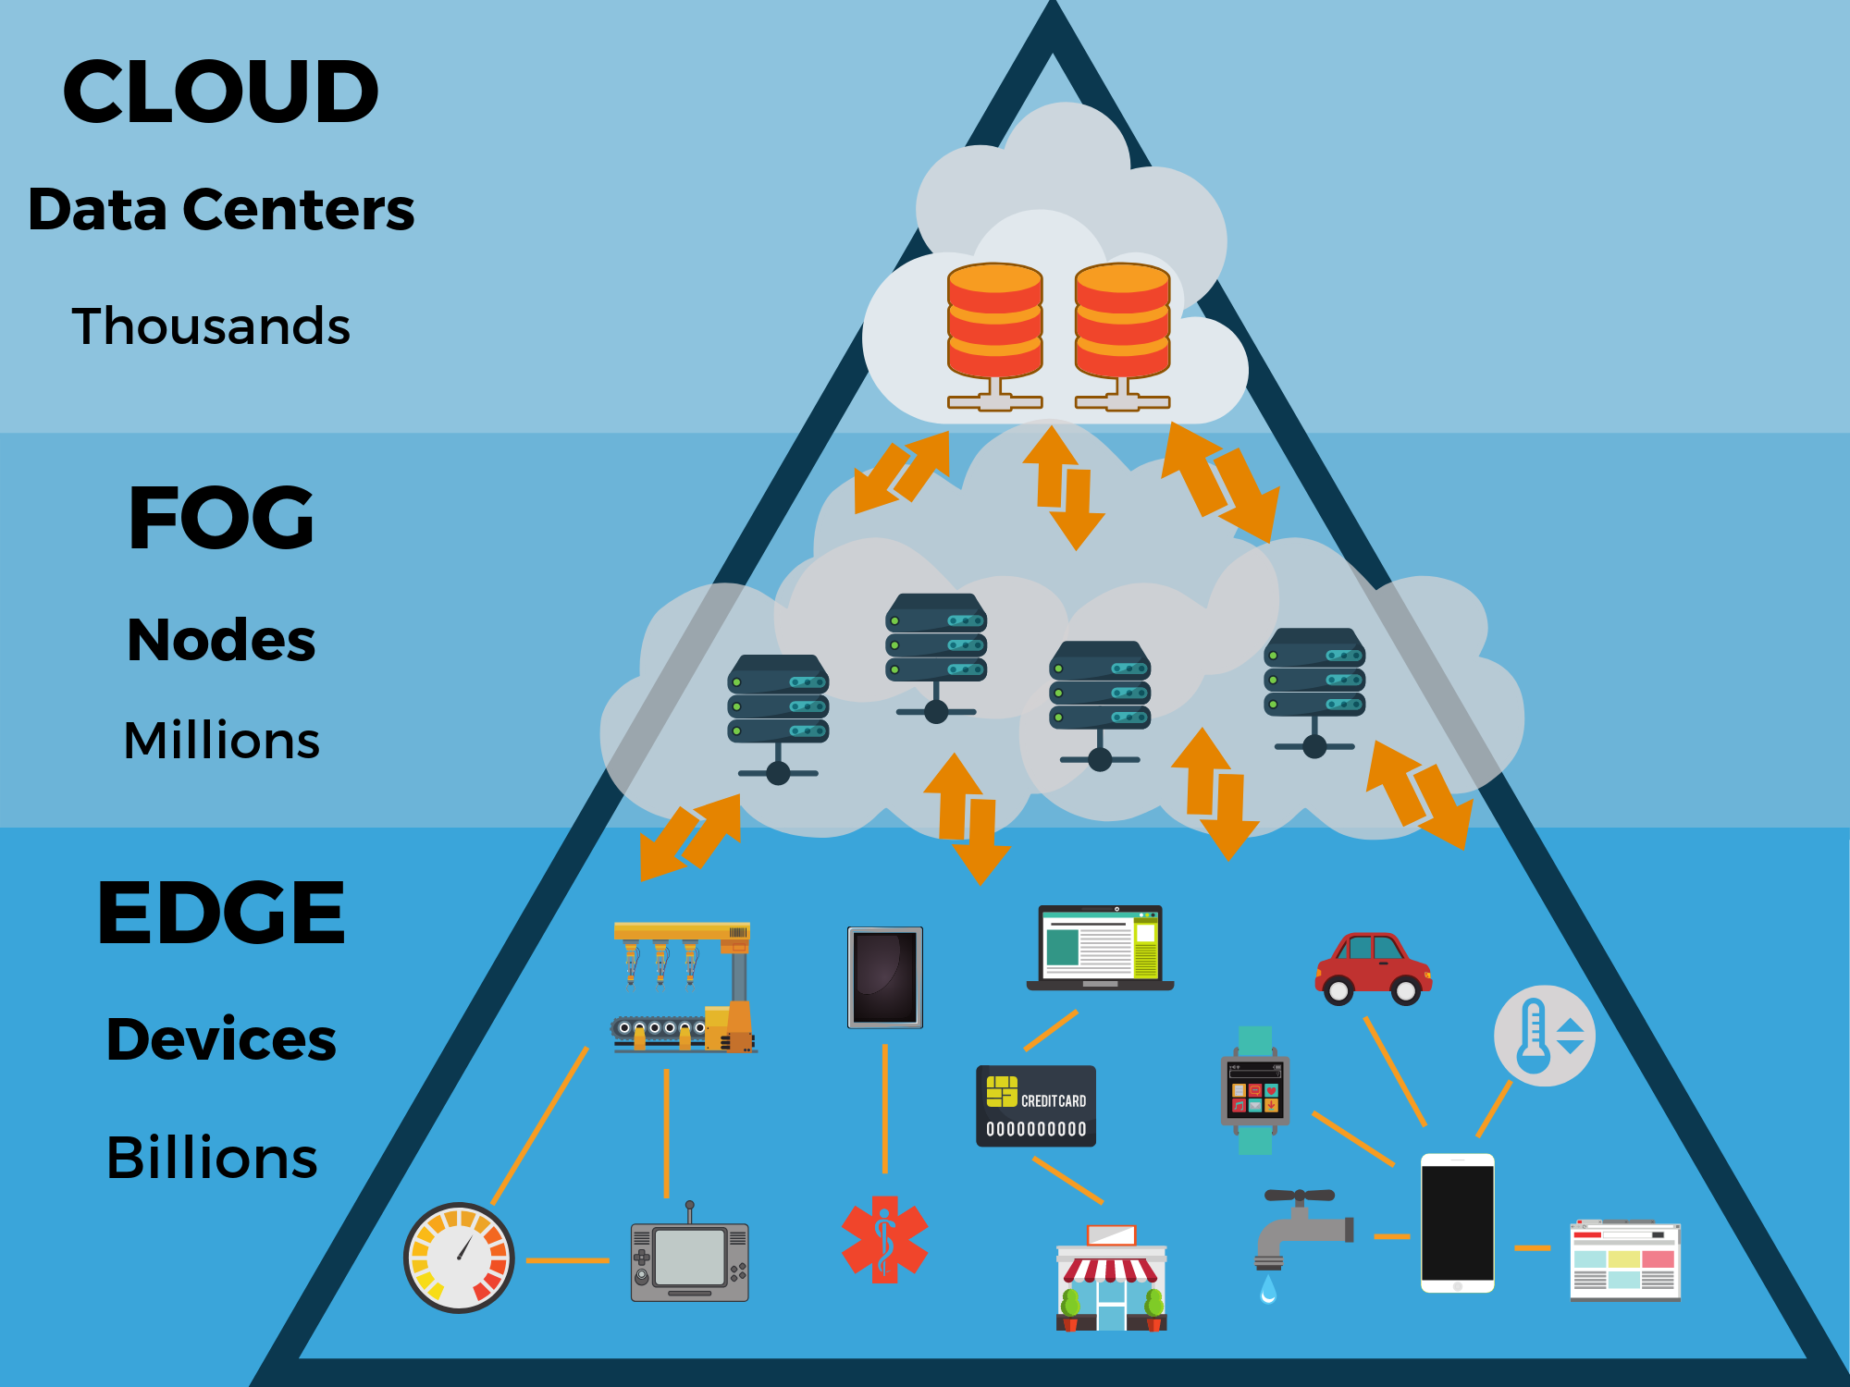

**Some real-life examples of both fog computing and edge computing:**

**Fog computing:**

In the healthcare industry, fog computing can be used to process data from patient monitoring devices in real-time. For example, a hospital could use fog computing to analyze data from wearable devices that track patients' vital signs, such as heart rate and blood pressure, to detect signs of distress and alert medical staff.

In the manufacturing industry, fog computing can be used to monitor the performance of machines on a factory floor. For example, a factory could use fog computing to analyze data from sensors that track machine performance and identify potential issues before they cause downtime.

In the transportation industry, fog computing can be used to improve safety and efficiency on the road. For example, a connected car could use fog computing to analyze data from sensors that track the vehicle's speed, location, and surrounding environment to detect potential hazards and alert the driver.

**Edge computing:**

In the retail industry, edge computing can be used to provide personalized recommendations to customers in real-time. For example, a retail store could use edge computing to analyze data from sensors that track customer behavior and purchasing patterns to offer personalized discounts and recommendations.

In the smart home industry, edge computing can be used to enable devices to operate offline. For example, a smart thermostat could use edge computing to adjust the temperature in a home based on the user's preferences, even if there is no network connectivity.

In the wearables industry, edge computing can be used to process data from health and fitness trackers in real-time. For example, a fitness tracker could use edge computing to analyze data from sensors that track the user's heart rate and activity level to provide real-time feedback and coaching.

1. **Highlights of characteristics of above.**

**key characteristics of edge computing:**

* Proximity: Edge computing involves processing data closer to where it is generated, rather than sending it to a central location for processing. This reduces the latency and improves the speed of processing.
* Decentralized: Edge computing distributes processing power across multiple devices, rather than relying on a central server. This reduces the load on the network and enables faster processing.
* Real-time: Edge computing is designed to enable real-time processing of data, allowing for faster decision-making and response times.
* Scalability: Edge computing is designed to be highly scalable, allowing it to handle large volumes of data from multiple sources.
* Security: Edge computing can be more secure than centralized computing because it reduces the attack surface area and can allow for local processing of sensitive data.
* Autonomous: Edge computing can enable autonomous devices that can operate independently of a centralized system or network, making them more reliable and resilient.
* Cost-effective: Edge computing can be more cost-effective than centralized computing because it reduces the need for expensive hardware and network infrastructure.

Overall, edge computing is a distributed computing model that enables data to be processed closer to where it is generated, allowing for faster processing, real-time decision-making, and improved scalability and security.

**key characteristics of fog computing:**

* Proximity: Fog computing involves processing data closer to where it is generated, similar to edge computing. However, fog computing typically involves processing data at a slightly higher level of aggregation, such as within a building or campus, rather than at the device level.
* Heterogeneity: Fog computing is designed to handle a wide variety of devices, data formats, and protocols, making it highly flexible and adaptable.
* Scalability: Fog computing is designed to be highly scalable, allowing it to handle large volumes of data from multiple sources.
* Real-time: Fog computing is designed to enable real-time processing of data, allowing for faster decision-making and response times.
* Security: Fog computing can be more secure than centralized computing because it reduces the attack surface area and can allow for local processing of sensitive data.
* Autonomy: Fog computing can enable autonomous devices that can operate independently of a centralized system or network, making them more reliable and resilient.
* Orchestration: Fog computing often involves the use of orchestration tools to manage the processing of data across multiple devices and networks.

Overall, fog computing is a distributed computing model that enables data to be processed closer to where it is generated, allowing for faster processing, real-time decision-making, and improved scalability and security. However, unlike edge computing, fog computing typically involves processing data at a slightly higher level of aggregation and is designed to handle a wider variety of devices and data formats.

1. **Why go for edge computing?**

There are several reasons why organizations may choose to adopt edge computing:

* Faster processing: Edge computing allows for processing data closer to the source, reducing latency and improving the speed of processing. This is particularly important for real-time applications that require fast response times.
* Improved reliability: Edge computing can improve reliability by allowing devices to operate independently of a centralized network or server. This means that if a network connection is lost, devices can still continue to operate.
* Cost-effective: Edge computing can be more cost-effective than traditional centralized computing because it reduces the need for expensive network infrastructure and can be done using less powerful devices.
* Increased security: Edge computing can be more secure than traditional centralized computing because it reduces the attack surface area and can allow for local processing of sensitive data.
* Improved scalability: Edge computing can improve scalability by allowing organizations to handle large volumes of data from multiple sources, without overburdening their network or servers.
* Improved compliance: Edge computing can help organizations comply with regulations that require data to be processed and stored locally.

Overall, edge computing can offer many benefits to organizations, including faster processing, improved reliability, cost savings, increased security, improved scalability, and improved compliance.

**Extra data**

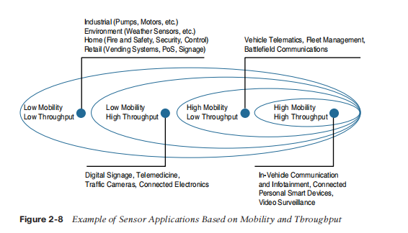

**Explain All sensors of the Smartphone in detail:**

**Accelerometer sensor of smartphone in detail**

An accelerometer sensor is a critical component of a smartphone that measures acceleration or the rate of change of velocity of an object in three-dimensional space. In simpler terms, it is a device that detects and measures motion and orientation of the phone in real-time.

In a smartphone, the accelerometer sensor is usually a small micro-electromechanical system (MEMS) sensor that works on the principle of capacitive sensing. It consists of a small proof mass that is suspended by springs inside a micro-machined cavity. When the phone moves, the proof mass moves too, and this motion is detected by the sensor.

The accelerometer sensor can measure both static and dynamic accelerations. Static accelerations are those due to gravity and do not change over time. They are used to measure the orientation of the phone relative to the earth's gravitational field, which is used to determine the screen orientation and adjust the display accordingly. Dynamic accelerations, on the other hand, are those due to motion or vibration and change over time. They are used to detect and measure the motion of the phone, such as shaking, tilting, and rotating.

Accelerometer sensors are used in a wide range of smartphone applications, including gaming, navigation, fitness tracking, and augmented reality. In gaming, they are used to detect the motion of the phone, which is used to control the game. In navigation, they are used to detect the orientation of the phone, which is used to determine the direction of travel. In fitness tracking, they are used to measure the number of steps taken and the distance covered. In augmented reality, they are used to detect the orientation of the phone relative to the real world, which is used to overlay virtual objects on the real world.

In conclusion, the accelerometer sensor of a smartphone is a critical component that measures motion and orientation of the phone in real-time. It is a small micro-electromechanical system (MEMS) sensor that works on the principle of capacitive sensing and is used in a wide range of smartphone applications, including gaming, navigation, fitness tracking, and augmented reality.

**Gyroscopesensor of smartphone in detail**

A gyroscope sensor is another important component of a smartphone that measures the rate of rotation or angular velocity of the device in three-dimensional space. It helps in detecting and measuring the orientation of the phone, especially during rotational movements.

In a smartphone, the gyroscope sensor is also a small micro-electromechanical system (MEMS) sensor that uses the principle of Coriolis effect to detect rotation. The sensor consists of a small vibrating proof mass that is suspended inside a cavity. When the phone rotates, the Coriolis force causes the proof mass to move perpendicular to the direction of rotation, and this motion is detected by the sensor.

Gyroscope sensors are used in combination with accelerometer sensors to provide more accurate measurements of motion and orientation of the phone. While accelerometers measure linear acceleration or motion, gyroscope sensors measure rotational motion. Together, they provide a more complete picture of the motion and orientation of the phone in three-dimensional space.

In a smartphone, gyroscope sensors are used in a variety of applications, including gaming, navigation, virtual reality, and augmented reality. In gaming, they are used to detect and measure the rotation of the phone, which is used to control the game. In navigation, they are used to detect and measure the orientation of the phone, which is used to determine the direction of travel. In virtual reality and augmented reality, they are used to provide a more immersive experience by detecting and measuring the orientation of the phone in real-time.

In conclusion, the gyroscope sensor of a smartphone is an important component that measures the rate of rotation or angular velocity of the device in three-dimensional space. It is a small micro-electromechanical system (MEMS) sensor that uses the principle of Coriolis effect to detect rotation. Together with accelerometer sensors, gyroscope sensors provide a more accurate measurement of motion and orientation of the phone and are used in a variety of applications, including gaming, navigation, virtual reality, and augmented reality.

**Magnetometerof smartphone in detail**

A magnetometer sensor is another important component of a smartphone that measures the strength and direction of the magnetic field in three-dimensional space. It helps in detecting the orientation of the phone relative to the Earth's magnetic field and is commonly used in navigation applications.

In a smartphone, the magnetometer sensor is also a small micro-electromechanical system (MEMS) sensor that uses a magnetoresistive or Hall effect sensor to detect changes in the magnetic field. The sensor consists of a small magnetic element that changes its electrical resistance in the presence of a magnetic field. When the phone moves, the magnetic field changes, and this change in resistance is detected by the sensor.

Magnetometer sensors are used in combination with other sensors, such as accelerometers and gyroscopes, to provide more accurate measurements of motion and orientation of the phone. Together, they provide a more complete picture of the orientation of the phone in three-dimensional space.

In a smartphone, magnetometer sensors are primarily used in navigation applications to detect the orientation of the phone relative to the Earth's magnetic field. This is used to determine the direction of travel and is commonly used in map and compass applications. Magnetometer sensors are also used in augmented reality applications to detect the orientation of the phone relative to the real world and overlay virtual objects on the real world.

In conclusion, the magnetometer sensor of a smartphone is an important component that measures the strength and direction of the magnetic field in three-dimensional space. It is a small micro-electromechanical system (MEMS) sensor that uses a magnetoresistive or Hall effect sensor to detect changes in the magnetic field. Magnetometer sensors are primarily used in navigation applications to detect the orientation of the phone relative to the Earth's magnetic field and are commonly used in map and compass applications. They are also used in augmented reality applications to overlay virtual objects on the real world.

**Proximity sensorof smartphone in detail**

A proximity sensor is an important component of a smartphone that detects the presence of nearby objects without physical contact. It is commonly used to turn off the display and disable touch input when the phone is held close to the user's ear during a call.

In a smartphone, the proximity sensor is typically a small infrared LED and detector that work together to detect the presence of an object. When an object is close to the sensor, the infrared light emitted by the LED is reflected back to the detector. The sensor measures the amount of reflected light, and if it exceeds a certain threshold, it indicates the presence of an object.

Proximity sensors are also used in other applications, such as detecting when the phone is in a pocket or face down on a table. In these cases, the sensor is used to disable touch input and prevent accidental actions.

In addition to infrared-based proximity sensors, some smartphones also use other types of sensors, such as ultrasonic or capacitive sensors, to detect the presence of nearby objects. Ultrasonic sensors emit high-frequency sound waves that bounce off nearby objects and are detected by the sensor. Capacitive sensors measure changes in the electrical field around the phone when an object is nearby.

In conclusion, the proximity sensor of a smartphone is an important component that detects the presence of nearby objects without physical contact. It is typically a small infrared LED and detector that work together to detect the presence of an object. Proximity sensors are commonly used to turn off the display and disable touch input when the phone is held close to the user's ear during a call, but they are also used in other applications, such as detecting when the phone is in a pocket or face down on a table. Some smartphones use other types of sensors, such as ultrasonic or capacitive sensors, to detect the presence of nearby objects.

**Ambient light sensor of smartphone in detail**

The ambient light sensor is an important component of a smartphone that measures the intensity and color temperature of the ambient light in the phone's environment. This sensor helps to automatically adjust the brightness and color temperature of the display to provide optimal viewing conditions for the user.

In a smartphone, the ambient light sensor is typically a small photodiode that converts light into an electrical signal. The sensor is placed on the front of the phone, usually near the earpiece or front-facing camera. When light enters the sensor, it generates an electrical current that is proportional to the intensity of the light. The phone's software then uses this signal to adjust the brightness and color temperature of the display.

The ambient light sensor is particularly useful in situations where the lighting conditions are constantly changing, such as when moving from indoors to outdoors, or when entering a dark room. By adjusting the brightness and color temperature of the display to match the surrounding environment, the ambient light sensor helps to reduce eye strain and improve the overall user experience.

In addition to adjusting the brightness and color temperature of the display, the ambient light sensor can also be used to conserve battery life. By reducing the brightness of the display in dimly lit environments, the sensor can help to extend the phone's battery life.

In conclusion, the ambient light sensor of a smartphone is an important component that measures the intensity and color temperature of the ambient light in the phone's environment. It is typically a small photodiode that converts light into an electrical signal, and is used to automatically adjust the brightness and color temperature of the display to provide optimal viewing conditions for the user. The ambient light sensor is particularly useful in situations where the lighting conditions are constantly changing, and can also be used to conserve battery life.

**Barometer sensor of smartphone in detail**

A barometer sensor is an important component of a smartphone that measures atmospheric pressure, and is typically used to provide information about altitude, weather, and location.

In a smartphone, the barometer sensor is typically a small electronic device that uses a MEMS (Micro-Electro-Mechanical System) to measure atmospheric pressure. When the sensor detects a change in pressure, it converts the change into an electrical signal that can be read by the phone's software.

Barometer sensors are particularly useful for providing information about altitude, which can be used for navigation and outdoor activities. By measuring changes in atmospheric pressure, the sensor can provide an estimate of the phone's current altitude, which can be useful for hiking, climbing, and other outdoor activities.

Barometer sensors can also be used to provide information about weather conditions. By detecting changes in atmospheric pressure over time, the sensor can provide an indication of whether the weather is likely to change, and can provide alerts and notifications to the user.

In addition to altitude and weather, barometer sensors can also be used to improve location accuracy. By combining information from the barometer sensor with other sensors, such as the GPS and accelerometer, the phone's software can provide more accurate location information, even in areas with poor GPS reception.

Barometer sensors are typically found in high-end smartphones, and are not present in all models. However, they can be a valuable addition for users who are interested in outdoor activities or who require accurate location information.

In conclusion, the barometer sensor of a smartphone is an important component that measures atmospheric pressure, and is typically used to provide information about altitude, weather, and location. Barometer sensors use a MEMS to measure pressure changes and convert them into electrical signals that can be read by the phone's software. They are particularly useful for providing altitude information for outdoor activities, and can also be used to improve location accuracy and provide weather alerts and notifications.

**GPS sensor of smartphone in detail**

The GPS (Global Positioning System) sensor is a crucial component of a smartphone that enables location-based services such as maps, navigation, and location-based recommendations.

GPS works by receiving signals from a network of satellites orbiting the Earth. The GPS sensor in a smartphone uses this information to determine the phone's location, speed, and direction. The GPS sensor is typically made up of a receiver that is capable of receiving signals from multiple GPS satellites.

In order to determine the phone's location, the GPS receiver uses a process called trilateration. This involves measuring the time it takes for a signal to travel from a GPS satellite to the receiver, and then using this information to calculate the distance between the receiver and the satellite. By measuring the distances to multiple satellites, the receiver can calculate the phone's location.

GPS sensors are particularly useful for navigation and maps, as they can provide real-time location information and directions. GPS sensors can also be used for location-based recommendations, such as suggesting nearby restaurants or attractions based on the phone's current location.

In addition to the GPS sensor, many smartphones also include additional location-based sensors, such as GLONASS (a Russian positioning system) and Galileo (a European positioning system). These additional sensors can improve location accuracy and provide better performance in areas where GPS signals are weak or blocked.

While GPS sensors are generally very reliable, they can be affected by certain factors such as weather conditions, tall buildings, and tunnels. In addition, GPS sensors consume a significant amount of battery power, so it's important to use them judiciously.

In conclusion, the GPS sensor is an important component of a smartphone that enables location-based services such as navigation, maps, and location-based recommendations. GPS sensors use a network of satellites to determine the phone's location, speed, and direction, and can be augmented by additional sensors such as GLONASS and Galileo for improved accuracy. While GPS sensors are generally very reliable, they can be affected by certain factors and consume significant battery power, so it's important to use them judiciously.

**Infrared sensor of smartphone in detail**

Infrared (IR) sensors are used in smartphones to provide a variety of features such as controlling TVs, air conditioners, and other electronic devices. IR sensors detect infrared light, which is emitted by electronic devices such as TVs, set-top boxes, and air conditioners. The IR sensor on a smartphone allows the user to control these devices remotely by emitting IR signals.

The IR sensor works by emitting a specific IR signal that corresponds to a particular electronic device, such as a TV or air conditioner. When the electronic device receives the IR signal, it performs the corresponding action such as changing the channel on a TV or adjusting the temperature on an air conditioner.

Infrared sensors are typically located on the top of a smartphone's front panel, and can be identified as a small black or red dot. In order to use the IR sensor, a user must first install a compatible remote control app on their smartphone. Once installed, the user can use the app to select the electronic device they wish to control, and the IR sensor will emit the corresponding IR signal.

One of the benefits of an IR sensor is that it allows users to control electronic devices without having to use multiple remote controls. Additionally, using a smartphone to control electronic devices can be more convenient and efficient than using traditional remote controls.

Infrared sensors are a relatively simple technology and are not known to consume significant amounts of battery power. However, it's important to note that not all smartphones include an IR sensor, and compatibility with different electronic devices may vary.

In conclusion, the infrared sensor on a smartphone allows users to remotely control electronic devices such as TVs and air conditioners. The IR sensor emits a specific IR signal that corresponds to a particular electronic device, allowing the user to control the device through their smartphone. While not all smartphones include an IR sensor, using a smartphone to control electronic devices can be more convenient and efficient than using traditional remote controls.

**Fingerprint sensor of smartphone in detail**

Fingerprint sensors are a common feature in modern smartphones and are used to authenticate the identity of the user. They work by capturing an image of the user's fingerprint, which is then compared to a previously stored image to determine if there is a match. If there is a match, the smartphone unlocks, granting the user access to its features and applications.

There are two main types of fingerprint sensors used in smartphones: optical sensors and capacitive sensors. Optical sensors work by capturing an image of the fingerprint using visible light, while capacitive sensors use an electric field to measure the ridges and valleys on the user's fingerprint.

Optical sensors are typically less expensive than capacitive sensors, but they are often slower and less accurate. Capacitive sensors, on the other hand, are generally faster and more accurate, but they are also more expensive.

In order to use the fingerprint sensor on a smartphone, the user must first register their fingerprint by scanning it multiple times. This creates a stored image of the fingerprint that is used for comparison each time the user attempts to unlock the device. Most smartphones allow for multiple fingerprints to be registered, allowing multiple users to access the device if needed.

One of the benefits of using a fingerprint sensor on a smartphone is that it provides a quick and convenient way to unlock the device without having to enter a passcode or pattern. It also provides an added layer of security, as it is more difficult for someone else to replicate the user's fingerprint than to guess a passcode or pattern.

Fingerprint sensors are generally considered to be secure and reliable, but they are not foolproof. Some users may have difficulty using the sensor if their fingers are wet or dirty, and there have been cases where fingerprint sensors have been fooled by high-quality replicas of a user's fingerprint. As a result, some smartphones now include additional security features such as facial recognition or iris scanning.

In conclusion, fingerprint sensors are a common feature in modern smartphones and provide a quick and convenient way to authenticate the identity of the user. They work by capturing an image of the user's fingerprint and comparing it to a previously stored image. While they are generally considered to be secure and reliable, they are not foolproof and some users may have difficulty using them.

**Heart rate sensor of smartphone in detail**

Heart rate sensors in smartphones are designed to measure a person's heart rate by detecting the changes in blood flow through the skin. This technology is typically based on photoplethysmography (PPG), which uses light to detect changes in the volume of blood in the blood vessels beneath the skin.

Here's how it works:

* A person places their finger over the heart rate sensor on their smartphone, which emits a beam of light onto the skin.
* The light penetrates the skin and is absorbed by the blood in the blood vessels, which causes the blood volume to change slightly.
* The sensor detects these changes in blood volume and uses algorithms to calculate the person's heart rate based on the time between each beat.
* The heart rate data can be displayed on the smartphone screen and may also be stored in the device's health app or other health-related applications.

Heart rate sensors in smartphones can be useful for monitoring exercise and fitness, as well as for detecting irregular heartbeats or other cardiac issues. They are also commonly used in conjunction with other sensors, such as GPS and accelerometers, to provide a more complete picture of a person's overall health and fitness. However, it's worth noting that heart rate sensors in smartphones may not be as accurate as medical-grade devices, so they should be used for informational purposes only and not relied upon for medical diagnosis or treatment.

**Camera sensor of smartphone in detail**

The camera sensor in a smartphone is the component responsible for capturing and converting light into digital images or videos. Smartphone cameras have evolved significantly over the years, and now include a range of features and capabilities.

Here are some key features of smartphone camera sensors:

* Image resolution: Camera sensors are measured in pixels, and the resolution determines the number of pixels in the image. Higher resolution sensors can capture more detail, but may require more processing power and storage space.
* Aperture: The aperture is the size of the opening in the camera lens, which controls the amount of light that enters the sensor. A wider aperture allows more light to enter the sensor, which can improve low-light performance.
* Optical Image Stabilization (OIS): OIS is a technology that helps reduce blur in photos and videos by compensating for camera shake. This is particularly useful for capturing sharp images in low light or when using a longer exposure time.
* Autofocus: Autofocus is a feature that automatically adjusts the focus of the camera based on the distance to the subject. This helps ensure that images are sharp and in focus.
* HDR (High Dynamic Range): HDR is a technique that combines multiple images taken at different exposures to create a single image with improved contrast and detail.
* Slow-motion and time-lapse recording: Many smartphone cameras can record slow-motion or time-lapse videos, which can be used to create unique and creative content.

Overall, smartphone camera sensors have become increasingly advanced, offering features and capabilities that were once only available in dedicated cameras. They have become a key selling point for many smartphones, as users are increasingly using their devices as their primary camera for capturing photos and videos.